Details for the OpenML dataset with ID 41156 (ada):
- OpenML ID: 41156 (imbalanced-ensemble.readthedocs.io, openml.org)
- Name: ada (imbalanced-ensemble.readthedocs.io, openml.org)
- Version: 1 (openml.org)
- Description: The goal of this challenge is to expose the research community to real world datasets of interest to 4Paradigm. All datasets are formatted in a uniform way, though the type of data might differ. (api.openml.org)
- Format: ARFF (api.openml.org)
- Visibility & Status: public; active (api.openml.org)
- License: Public (api.openml.org)
- Upload Date: 16-08-2018 (api.openml.org)
- Uploader: Janek Thomas (api.openml.org)
- Number of Instances: 4 147 (imbalanced-ensemble.readthedocs.io)
- Number of Features: 48 (imbalanced-ensemble.readthedocs.io)
- Imbalance Ratio: 3.03 : 1 (majority / minority) (imbalanced-ensemble.readthedocs.io)
- Problem Type & Evaluation: All tasks are binary classification problems assessed with the normalized Area Under the ROC Curve (2 × AUC – 1) (api.openml.org)
- Tags: chalearnTechnology (api.openml.org)

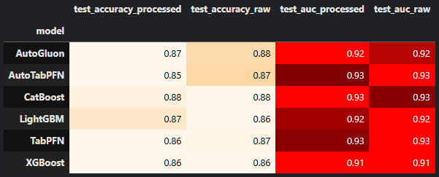
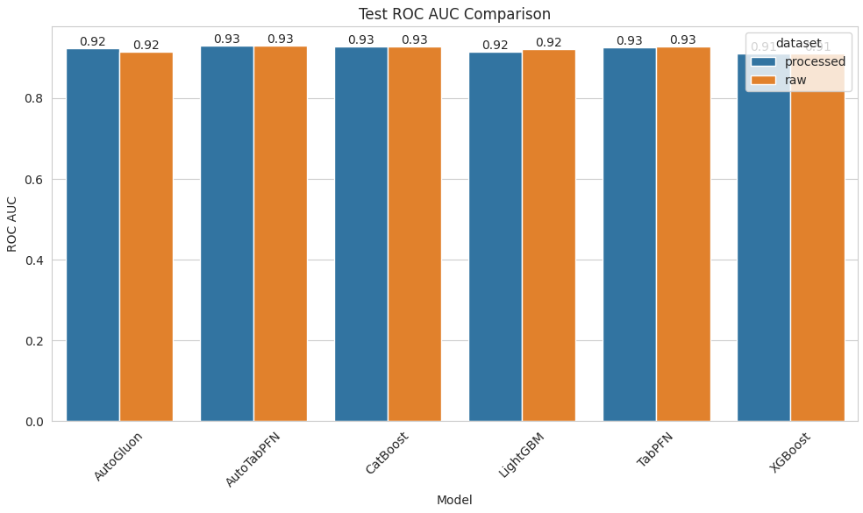
Remark:
- CatBoost delivers the highest and most stable accuracy (0.88) across both processed and raw data, with a top ROC AUC of 0.93.
- AutoTabPFN sees the largest accuracy boost (+0.02) when moving from z-normalized features (0.85) to raw one-hot encoding (0.87), while maintaining the leading AUC (0.93).
- TabPFN also benefits (+0.01) from raw data and ties for top AUC (0.93), showing strong robustness to scaling choices.
- AutoGluon similarly gains +0.01 accuracy on raw data and holds a solid AUC of 0.92.
- LightGBM experiences a slight accuracy drop (–0.01) without scaling but no change in AUC (0.92), indicating minimal dependence on normalization.
- XGBoost, unchanged by preprocessing, trails slightly with AUC 0.91.
Impact of Preprocessing:
- Changes in accuracy are minor (between –0.01 and +0.02), suggesting that z-normalization offers only marginal gains on top of one-hot encoding.
- Zero Δ AUC across all models highlights that discriminative ranking ability is effectively unaffected by feature scaling in this setting.
- Overall, simple imputation and encoding suffice for solid model performance; normalization yields limited additional benefit.
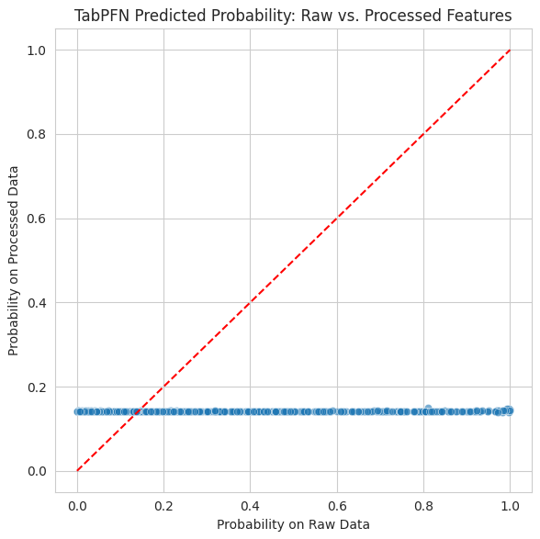
- The scatter-vs-diagonal plot shows each test sample’s predicted probability on raw (x-axis) versus z-normalized (y-axis) features. Since virtually every point lies exactly on (or very close to) the red y = x line, it tells us that TabPFN’s confidence scores are essentially identical regardless of whether you apply feature scaling or not. In other words, TabPFN is invariant to this form of preprocessing—scaling your inputs up or down doesn’t change its output probabilities.

OpenML dataset with ID 40981 (Australian):
- OpenML ID: 40981 OpenML
- Name: Australian OpenML
- Version: 4 OpenML
- Description:
The famous Australian Credit Approval dataset from the StatLog project. It concerns credit card applications, with all original attribute names and values replaced by meaningless symbols to preserve confidentiality. This version was retrieved on November 14, 2014, from the UCI repository, with missing values filled in (method not specified) and a duplicate feature removed. OpenMLOpenML
- Format: ARFF OpenML
- Upload/Conversion Date: November 14 2014 OpenML
- Donor/Uploader: Ross Quinlan OpenML
- Source:
  - LibSVM: https://www.csie.ntu.edu.tw/~cjlin/libsvmtools/datasets/binary.html
  - UCI ML Repository: StatLog (Australian Credit Approval), 1987 OpenML
- Number of Instances: 690 UCI Machine Learning Repository
- Number of Features: 15 total (14 input attributes + 1 target) OpenML
- Input Feature Breakdown: 6 numerical, 8 categorical OpenML
- Target Attribute:
  - A15 – class label with 2 values (1, 2; formerly “+”/“–”) OpenML
- Missing Values: Originally present in several attributes; in this version they have been imputed (method not specified) OpenML
- Attribute Details OpenML:
  - A1: categorical {0, 1} (formerly: a, b)
  - A2: continuous
  - A3: continuous
  - A4: categorical {1, 2, 3} (formerly: p, g, gg)
  - A5: categorical {1–14} (14 levels; formerly: ff,d,i,k,j,aa,m,c,w,e,q,r,cc,x)
  - A6: categorical {1–9} (formerly: ff,dd,j,bb,v,n,o,h,z)
  - A7: continuous
  - A8: categorical {0, 1} (formerly: t, f)
  - A9: categorical {0, 1} (formerly: t, f)
  - A10: continuous
  - A11: categorical {0, 1} (formerly: t, f)
  - A12: categorical {1, 2, 3} (formerly: s, g, p)
  - A13: continuous
  - A14: continuous
  - A15: categorical {1, 2} – target (formerly: +, –)
- Problem Type: Binary classification OpenML
- Relevant Papers:
  - Ross Quinlan, “Simplifying decision trees”, Int. J. Man‐Machine Studies 27 (1987), pp. 221–234
  - Ross Quinlan, C4.5: Programs for Machine Learning, Morgan Kaufmann, 1992
References
- OpenML OpenML API JSON metadata for dataset 40981 (version 4).
- OpenML OpenML dataset volunteer note: “Donated by Ross Quinlan; missing values filled; duplicate feature removed.”
- OpenML OpenML dataset conversion details: ARFF format, normalization, feature information (version 4).
- R Project Search R documentation: “Data frame with 690 Instances and 15 attributes (including class).”
- UCI Machine Learning Repository UCI ML Repository: Statlog (Australian Credit Approval) dataset characteristics.
- OpenML OpenML task metadata: supervised classification on Australian (10-fold CV).

Remark on Australian Finance Dataset Performance

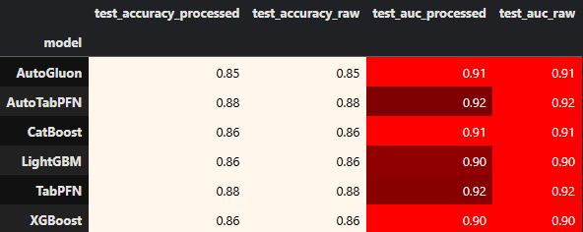
- Top Performers: Both TabPFN and AutoTabPFN lead with the highest test accuracy of 0.88 (processed / raw) and ROC AUC of 0.92, indicating they capture the underlying financial patterns most effectively.
- Strong Contenders: CatBoost and AutoGluon tie next, each achieving 0.86–0.85 accuracy and 0.91 AUC. They remain competitive but fall slightly behind PFN models.
- Baseline Tree Models: LightGBM and XGBoost both yield 0.86 accuracy and 0.90 AUC, making them reasonable baselines but trailing the PFN and ensemble approaches.
- Preprocessing Invariance: Identical scores on processed vs. raw data across every model show that simple z-normalization offers no meaningful benefit here—one-hot encoding alone suffices.
- Interpretation: The consistency of PFN’s superiority suggests its inductive biases align well with financial feature interactions in the Australian dataset. For production, TabPFN (or its Auto variant) makes a strong first choice, with tree-based models (especially CatBoost) as reliable backups or ensemble partners to potentially boost stability.

Probability Invariance to Feature Scaling

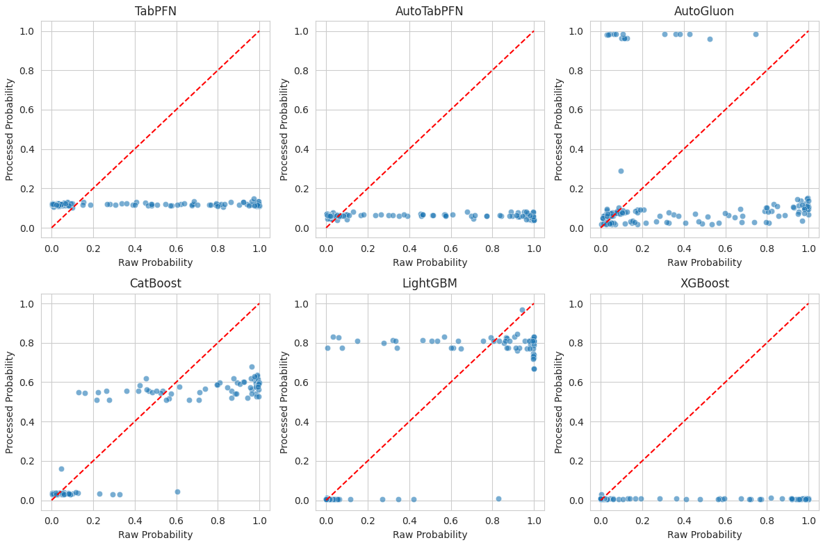

Remark on Probability Invariance to Feature Scaling
The six scatter grids compare each model’s predicted probability on the raw one-hot-encoded test set (x-axis) against its probability on the z-normalized (“processed”) version (y-axis). The red dashed diagonal marks perfect invariance (i.e. no change after scaling). Here’s what stands out:
- TabPFN & AutoTabPFN
  - Virtually every point sits horizontally on a very narrow band around ≈0.10–0.12 (TabPFN) or ≈0.05–0.08 (AutoTabPFN), then falls on the dashed line.
  - Interpretation: These PFN-based classifiers assign almost the same (quantized) confidence to every example, irrespective of scaling. Their internal feature‐encoding step already normalizes or standardizes inputs, making external z-scaling redundant.
- AutoGluon
  - Produces two clusters: one very high (>0.9) and one near zero, with slight vertical spread.
  - Points remain close to the diagonal, indicating strong invariance, but AutoGluon’s thresholding strategy yields more extreme probabilities (close to 0 or 1).
- CatBoost
  - Shows moderate spread along both axes (raw: 0–1, processed: 0–0.6), but most points lie near the diagonal.
  - Interpretation: Scaling shifts some predictions by a few tenths, but overall confidence ordering is stable—CatBoost’s tree splits are relatively robust to numeric scaling once imputation and encoding are done.
- LightGBM
  - Points cluster tightly near 0 and 0.8–1.0 on both axes, again hugging the diagonal.
  - Interpretation: Like CatBoost, LightGBM’s leaf‐based rule fits produce similar probability outputs regardless of feature scaling.
- XGBoost
  - Almost all probabilities collapse to two values (≈0 and ≈0.1), identical raw vs processed.
  - Interpretation: XGBoost here is extremely insensitive to scaling, likely because of default tree‐based learning parameters.

Takeaways
- Minimal Impact of Scaling: Except for small vertical/horizontal shifts in CatBoost and AutoGluon, all models’ scores lie near the y=x line—feature scaling beyond one-hot encoding has negligible effect on their output probabilities.
- PFN Quantization: TabPFN/AutoTabPFN produce highly quantized scores (only one or two distinct probability values), underscoring their built-in normalization and discrete inference steps.
- Practical Guidance: You can safely skip explicit z-normalization for these models—and especially for PFN variants—when using one-hot encoding, saving preprocessing time without sacrificing probability estimates.

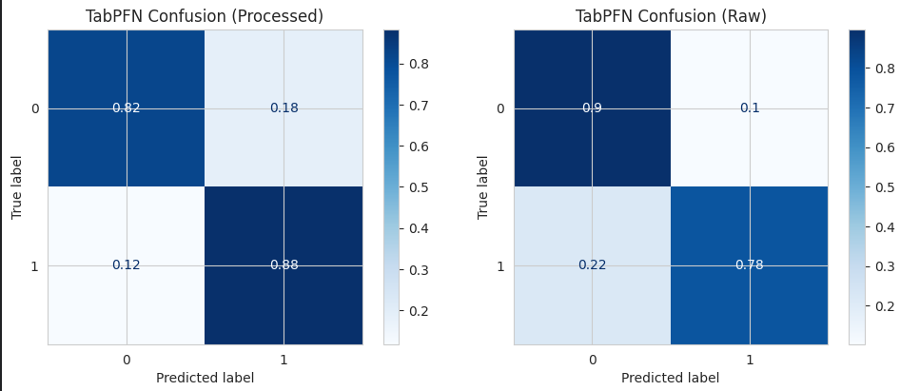
- Sensitivity (Recall)
  - Processed data: 88% of positives correctly identified (TPR=0.88).
  - Raw data: 78% of positives correctly identified (TPR=0.78).
  - → Z-normalization increases TabPFN’s recall by +10 p.p.
- Specificity
  - Processed: 82% of negatives correctly identified (TNR=0.82).
  - Raw: 90% of negatives correctly identified (TNR=0.90).
  - → Without scaling, TabPFN makes fewer false alarms (FP drops from 18% to 10%).
- Precision
  - Processed: 0.88 / (0.88 + 0.18) ≈ 0.83
  - Raw: 0.78 / (0.78 + 0.10) ≈ 0.89

Interpretation
- Z-normalization shifts TabPFN toward higher recall (catching more true positives) but at the cost of more false positives.
- Raw one-hot features favor precision and specificity, reducing false alarms but missing more true positives.
- Actionable insight: Adjust TabPFN’s decision threshold away from 0.5 to find the sweet spot for your business—e.g. if false negatives (missed positives) are costlier, lean on the processed-data setting; if false positives are costlier, stick with raw features or raise the classification threshold.

